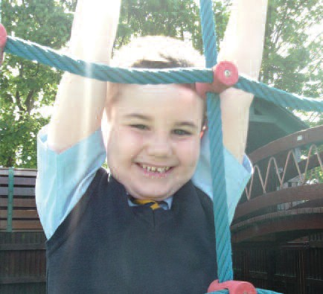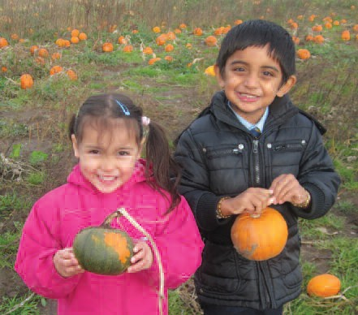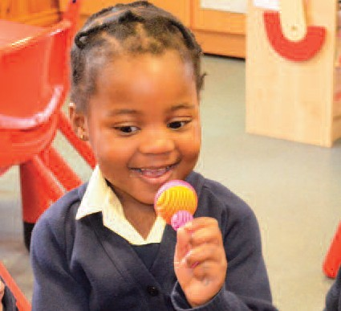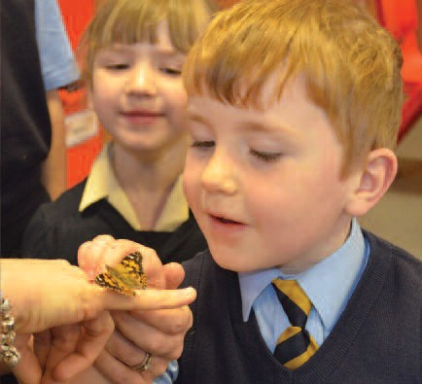

Where every child matters

Outstanding facilities

Green Meadow Independent Primary School

Headteacher’s Welcome Message,
Welcome to Green Meadow Independent Primary School and thank you for taking the time to enquire about our school. We are a small school situated in Lowton Village, Warrington. Our children at Green Meadow Independent Primary School are the centre of all we do. Being a small establishment, we are able to focus on the individual needs of each child and provide a tailored approach to learning and support, allowing everyone to reach their full potential. We understand that we are educating the future of this country and as a result our curriculum and teaching is aimed at developing our children to be independent, well rounded young citizens who recognise the need for taking care of our planet and the people on it.
Green Meadow offers children excellent opportunities to learn in a vibrant, stimulating environment which where they feel safe, valued and challenged. Our staff know each and every child and make sure they are fully involved in their learning. Our pupils are happy and confident individuals who leave us prepared for their next educational step, whether continuing in independent education or into mainstream secondary after developing firm foundations for learning.
I know that choosing a school for your child can be one of the most important decisions you make. The decision to join Green Meadow is one you will look back on with confidence that you made the right choice. Offering an affordable, bespoke private education to support every pupil become the best they can be is at the core of all we do. The only way to truly experience everything our school has to offer is to come and visit us. Please feel free to ring on 01942 671138 or email me directly at greenmeadowhead@gmail.com to arrange a personal tour and discussion around your child’s needs and what we have to offer.
Looking forward to hearing from you,
Lyn Hackett
Headteacher

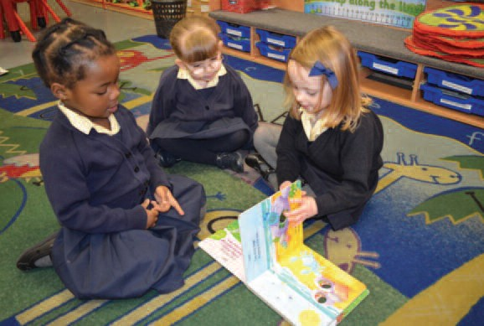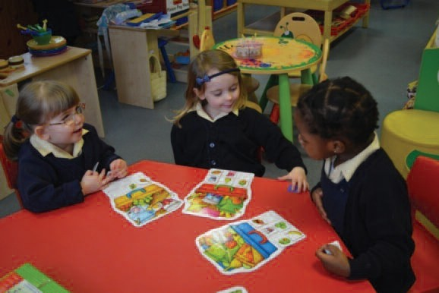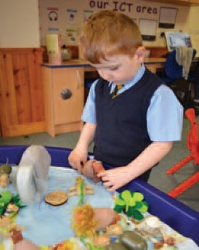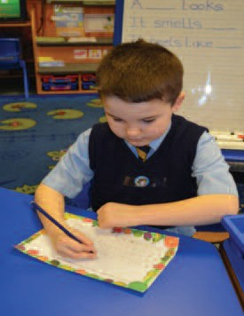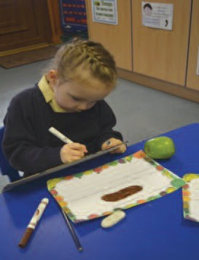Contents
Our School
Philosophy and Academic Aims Welcome Introduction
School Ethos Admission Organisation
Termly Reports Parent Comments Parent Evenings
Our School Day
Our School Day Uniform and Equipment Lunch
Healthy Schools Example Menus
Curriculum
Introduction
Additional Educational Needs Gifted & Talented
English as an Additional Language Intended Topics and Celebrations Homework
Core Subjects
- Literacy/Mathematics
- ICT/Science
Foundation Subjects
- History/Geography
- RE/Music & Drama
- Foreign Languages/PE
Clubs and Extra-Curricular Activities
Introduction Breakfast Club After School Club Holiday Club
Educational Day Visits Extra-Curricular Activities
Our Classes
Kindergarten Class Reception Class Key Stage 1
Key Stage 2

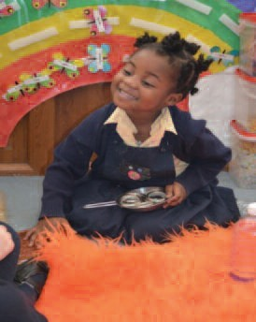

Our School

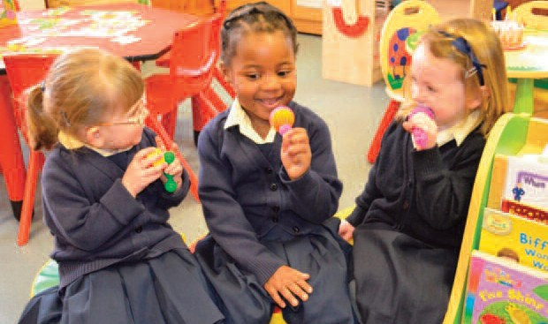

Pupils behave well. They show respect for each other and their teachers. (Ofsted 2020)

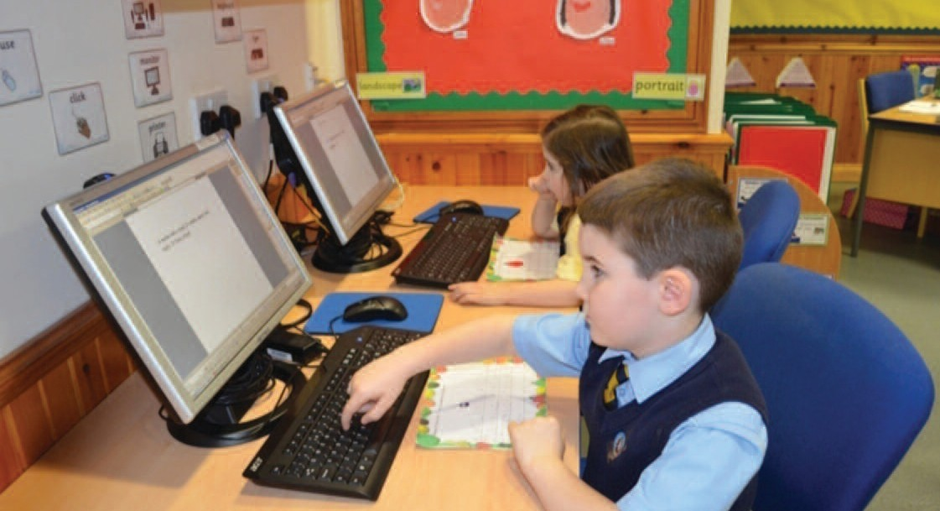

In lessons, pupils said thatteachers try to make learning fun. All leaders are ambitions for all learners. (Ofsted 2020)

Green Meadow Independent Primary School “Where Every Child Matters”

Philosophy and Academic Aims

★ To provide a happy and stimulating environment for study.
★ To provide a safe and secure environment, in which pupils can thrive.
★ To treat all pupils as individuals.
★ To encourage pupils to strive for academic excellence.
★ To develop knowledge, skills and understanding.
★ To offer all pupils a broad and balanced curriculum.
★ To foster a spirit of enquiry.
★ To develop every individual’s potential.
★ To equip pupils with technological expertise.
★ To prepare pupils for future educational and working environments.
★ To promote community and global awareness.
★ To encourage self-discipline and a high standard of behaviour.
★ To develop positive relationships.
★ To promote self-confidence and independence, but also co-operation.
★ To foster and promote caring for others and spiritual development.
★ To promote healthy choices.
★ To encourage physical and mental fitness.

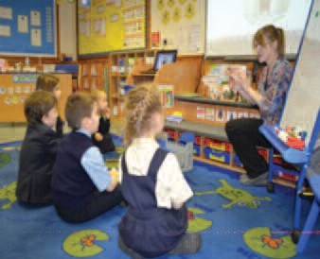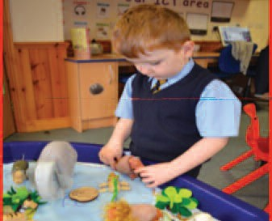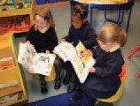

Welcome Introduction
Green Meadow Independent Primary School welcomes children from the age of three to eleven years. With a small, happy and friendly atmosphere, the school aims to inspire its pupils academically, culturally, morally and spiritually. Small class sizes and dedicated, specialist teachers ensure that the needs of all pupils are met, from high achievers to those who may need a little extra support.
The school’s objective is to help children thrive and give each individual child the opportunity to reach their full potential.
Our school is a friendly and happy place, buzzing with activity and positive energy. Staff support children ensuring a smooth transition from Kindergarten to Reception Class and onto Key Stages 1 and 2.

Parents and carers are overwhelmingly supportive of the school.One parent commented, ‘The school has changed our children’s lives. They are now confident, eager to learn and happy going into school.’
(Ofsted 2020)

School Ethos
At Green Meadow Independent Primary School our purpose is to enable children to fulfil their full potential.
★ We will encourage them in independent thought, curiosity and love of learning, which will help them grow in self-worth and confidence within a caring, safe and supportive environment.
★ We believe that all children should experience the same opportunities and that they have an entitlement to a broad education that equips them with the skills for life.
★ We believe that praise is important and that every child should feel valued.
★ We aim to impart the shared values of respect for others and our environment, personal responsibility, tolerance and understanding of right and wrong, so that our pupils may become valued members of the community in which they live.

Admission
Application for admission to the school can be submitted for consideration at any time. There are 3 stages to enrolling your child at Green Meadow Independent School.
Stage 1 - Firstly, we would invite you and your family to visit the school for a personal tour where you would be able to see our outstanding facilities, ask any questions and speak with our outstanding teachers.
Stage 2 - Parents are asked to complete the enrolment document and at this point a date can be set for your child’s inspire session.
Stage 3 - During their inspire session your child will spend the day with their peer group joining in with lessons and activities. They will also gain an insight into the day-to-day life of Green Meadow School.

Organisation
Green Meadow Independent Primary School is in a purpose-built building with 7 classrooms and facilities over two levels. Adjacent to the school and occupying the same site is First Steps Nursery which is also owned by Mr and Mrs Green. Green Meadow School is registered for up to 168 pupils aged from three years to eleven years.
The Kindergarten is intake is 24 children per year and all children are required to wear the Green Meadow uniform and adhere to its registration rules.
All school classrooms cater for our preferred teaching group of 24 pupils. Each of the seven classrooms has interactive whiteboards and are large, bright and well equipped.
Green Meadow Primary is a good school.
The vision and commitment of the headteacher to provide a nurturing and caring environment for all pupils is palpable throughout the school.
headteacher’s strong vision
With the
and the
support of the management team, staff
provide good opportunities for pupils to grow in confidence, enjoy school and make good progress.
(Ofsted 2020)

Half Term Reports
At Green Meadow School we provide termly reports for all year groups including Kindergarten. The report covers what the children have been learning and the progress they have made. The Early Years reports cover the Foundation Stage which is separated into 7 areas.
Within Key Stage 1 and 2 the reports cover all core and the foundation subjects. At the end of each term the report will show you your child’s attainment levels.
A more detailed written report is sent home towards the end of the year to summarise achievement and attainment and parents are given the opportunity to discuss this report should they wish with the class teacher.

Parents receive detailedinformation about how their children are achieving at school.
(Ofsted 2020)

Parental Comments
★ “It is very clear from the reports, photographs and work folder that he has had a fantastic start to his school life.” Parents of a Foundation Stage pupil
★ “We would like to take this opportunity to thank all staff for making the transition from nursery to school so successful.” Parents of a Foundation Stage Pupil
★ “His love of school is a result of the ‘sense of belonging’ from the community spirit that has been embedded since the school opened its doors.” Parents of a Foundation Stage pupil
★ “I was eager for his confidence to grow and due to all your efforts my hopes have been exceeded beyond all expectations.” Parents of a Reception pupil
★ “Thank you for the truly fantastic job you have all done in supporting him through his first year of school.” Parents of a Reception pupil

Parent Consultation Evenings
In order to provide parents with information on pupil progress and development, we hold three parent consultation evenings throughout the year. These are in addition to informal parent ‘drop-in sessions which are at the end of each term.
The first is held in October in order for you to meet your child’s class teacher and discuss your child’s progress.
The second evening is held in the middle of the academic year (March/April) to discuss your child’s progress and identify any strengths and ‘next steps’ within their developmental areas.
An open evening is held at the end of the year, in July, where parents are invited in to school to view an exhibition of the wonderful work that has been produced throughout the year. It also gives parents a chance to meet their child’s next teacher for the following academic year.

★ “We have seen a big improvement in his confidence and feel this has aided his overall performance.”
Parents of a Year 6 pupil.
★ “Without all your help and encouragement he would not have progressed so much.” Parents of a Year 4 pupil
★ “He enjoys school life and is looking forward to the next academic year.”
Parents of a Year 5 pupil
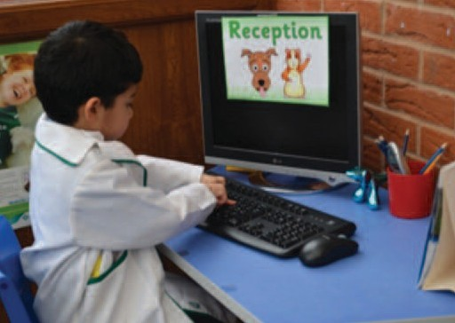★ “We now know that the decision to move him to Green Meadow was the right one.” Parents of a Year 6 pupil

Our School Day

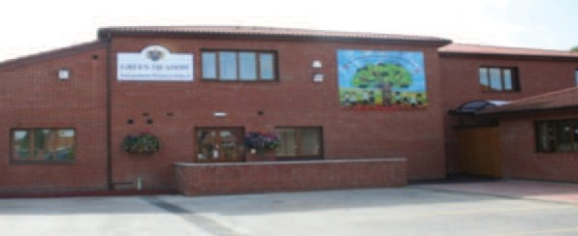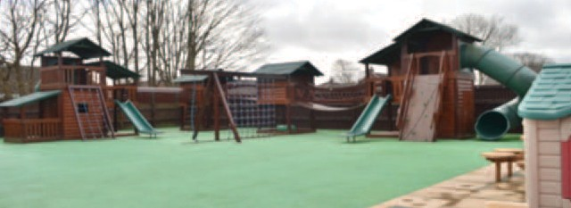

Our School Day
Our day begins at 8.45am and ends at 3.45pm for Reception and Key Stage 1 and 4.00pm for Key Stage 2. Children are requested to arrive at school between 8.45am and 8.50am where they will be met by a member of staff and the school doors will be opened. Before this time, the school is not responsible for the safety of the children on the school premises. Registration takes place promptly at 8.55am and again at 1.15pm. All lessons start promptly at 9.00am. All children are collected from their classroom at the end of the day via the outside classroom door.
For those families needing an earlier start to the day we offer a breakfast club starting from 7.30am. Children are able to choose from a selection of cereals, toast, fruit and drinks before school begins. Staff will escort your child to their classroom in time for registration. We also have an extra club starting at 8.30am where children do not need breakfast but just an earlier start. At the end of the school day we also provide various mini afterschool clubs. These clubs aim to cater for a variety of interests, activities and educational experiences. Our main after school club finishes at 6.30pm and whilst there the children receive a hot meal.
When dropping off or collecting your child please drive safely and park considerately. Cars should be parked away from school premises as children can be walked into school via the footpaths at the entrance.

Uniform and Equipment
Parents are able to order their child’s uniform from a local school outfitter who have both a shop and online ordering available. We expect all children to wear full uniform at all times
and a list of our uniform is in your child and family’s welcome pack.

Lunch
Lunch is a time children enjoy together - whether a hot school dinner or sandwiches. Our school hall becomes our dining room where children eat their lunch during one of three sittings. School dinners are cooked daily on site in our school kitchen. All our meals meet new Government standards and are nutritionally analysed. Throughout the school all children are offered a choice of meal from our menus. Menus always include a hot meal, sandwich or jacket potato with a choice of healthy filling. We also have a variety of special menus available such as vegetarian, dairy free etc. Please be aware that all meals are inclusive with your school fees.
W ask that children do not bring food from home so we can keep a close eye of foods which may contain allergens. Children are given a drinks bottle on enrolment at the school. All snacks are provided at the school with a variety of fruit and vegetables.

Healthy Schools
All our meals are healthy and nutritious and prepared on site by our qualified cooks. We have been graded a Level 5 (the highest award from the food standard agency for hygiene). In addition to this, we also gained a Healthy Business Award for the food we prepare for the children. For this award we were judged on the content of our menus and the nutritional value they provided. We are keen to continue promoting healthy lifestyles to all involved with the school. Healthy children achieve well at school. It is our aim to support healthy lifestyle decisions and to

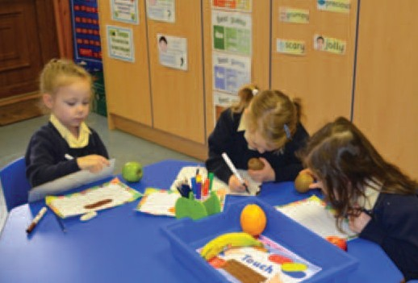educate our children so that these decisions are informed by an awareness, knowledge and
understanding of health and wellbeing.

Snacks
At break-time we have a fruit and vegetable option only policy. All children will receive a healthy well- balanced snack at their morning break by the school. This will include water, milk, juice, wholemeal bread, freshly sliced vegetables and fresh seasonal fruit.
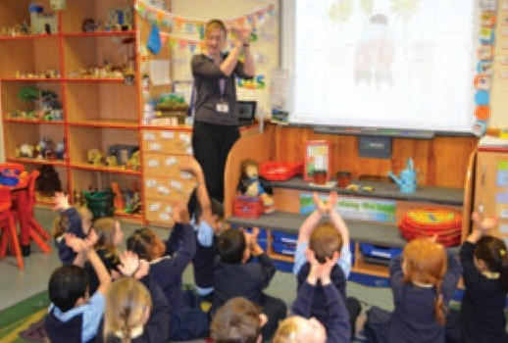All children are provided with a water bottle with their name on, so that they can have a drink at any time during the day including in the class. No sugary drinks of any kind, including flavoured water, should be brought into the school.
When your child begins attending Green Meadow you will be asked about their cultural background, dietary requirements and allergies. We do our best to cater for these requirements.

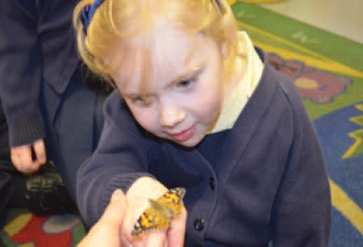

Menu Example
Fish pie and vegetables Chicken kebabs & savoury rice Homemade Vegetarian dish Choice of sandwiches
Baked potato & fillings
•••••••
Homemade carrot cake Homemade biscuits Fresh Fruit or yoghurt

Curriculum

Pupils show a good level of interest in their lessons and are enthusiastic about their learning. Attitudes to learning are exceedingly positive throughout the school.
(Ofsted 2020)

Introduction
We want all our children to experience success and enjoy their learning whilst at school. We aim to achieve this through our excellent high standards of learning and teaching within a happy, structured and caring environment.
Green Meadow has developed a real strength in the development of meaningful documentation which provides the basis for very effective teaching and learning. Through a variety of teaching methods and strategies, we aim to instill children with an enthusiasm for learning and prepare them for future school life.
The quality of teaching is strong and enables pupils to make excellent progress in their learning across a wide range of subjects. The quality of teacher’s planning is excellent throughout the school. The school has a systematic and successful approach to lesson planning which provides secure support for staff, and which is consistently reviewed in the light of teacher’s responses. The target for pupils to achieve in each lesson are clearly identified and shared with the pupils.
In the Early Years there is an appropriate balance between focused learning and extensive opportunities for continuous learning in the stimulating classroom and outdoor environments. Teachers throughout the school have excellent skills in questioning pupils and adding deeper layers of learning to ensure that they are challenged sufficiently at all times. There is much focused conversation illustrating how pupils understand what they are doing and testing their imaginative ideas.
Arrangements for the assessment of pupil’s progress are exemplary. The head teacher places a strong emphasis on ensuring that no child is left behind as a result of insufficient challenge or support.
Within the Early Years Foundation Stage, KS1 and KS2 learning, the curriculum at Green Meadow Independent Primary School aims to provide opportunities for all pupils to develop and enjoy learning through stimulating planned lessons. We build on pupils’ strengths, interests and experiences and develop their capacity to learn and work both independently and collaboratively. By providing a rich and varied programme the pupils are able to apply knowledge and understanding to make informed judgments and decisions.

Pupils attain highly in reading, writing and mathematics at the end of KS2
(Ofsted 2020)

The academic programme at Green Meadow Independent Primary School is designed to accommodate a wide range of abilities and backgrounds. Our pupil/teacher ratio is generous, allowing for small classes and consequently a great deal of individual attention. Pupils are regularly assessed to highlight their strengths and need for extra support. Teaching methods will combine the best of traditional approaches with modern resources such as interactive white boards. Children are encouraged to achieve their full potential through our understanding of their individual learning styles and through extension work.
The core subjects of English, Mathematics, ICT and Science are taught by experienced teachers, providing a high-quality education in a caring and supportive environment. Our enriched curriculum will focus on the basics of reading, writing, handwriting, spelling and grammar in Literacy and number, shape, measures, data-handling and problem solving in Mathematics.

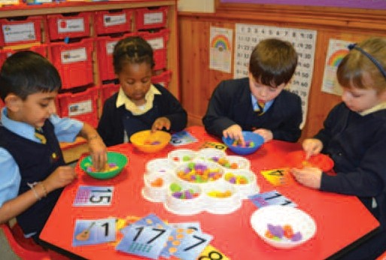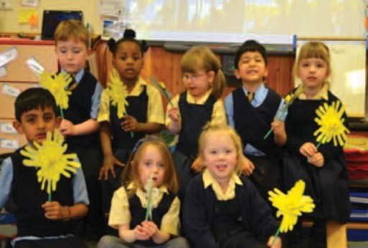

Additional Educational Needs
We are able to cater for children with Additional Needs and have experience of dyslexia, dyspraxia, ADHD and ASC. We can provide specialist one-to- one SEN support where appropriate. As we are a non-selective school, we do not assess children for the Reception intake. However, intake at Years 1 and above involves a baseline assessment and we would make a judgement on an individual basis to ensure we can meet the needs of all children at the school. Additional SEN support is invoiced separately.

Gifted, Able and Talented
Our school will have, at any time, a number of able, talented or gifted pupils. We recognise academic and practical performance, as well as those who show outstanding artistic, musical and creative talent, physical skills, leadership qualities and the ability to process ideas and information.
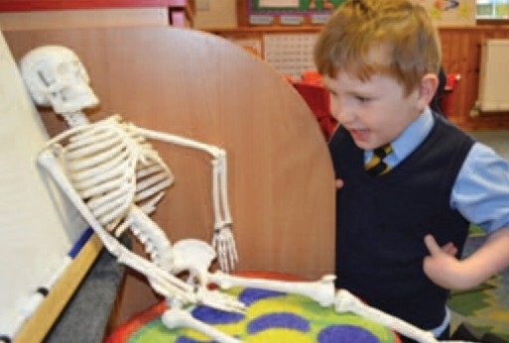As a school, we aim to nurture and develop the range of talents and gifts the children have. Through collaboration with parents, we identify these talents and gifts and seek opportunities, both in and out of school, to provide the best environment to challenge and enrich the learning of these children.

English as an Additional Language (E.A.L.)
We build on the children’s cultural and linguistic experiences to develop their understanding and use of English. We welcome parents and carers into school and embrace opportunities that will enrich the culture of our school community.

Leaders ensure that pupils read widely. They have invested in high-quality texts to stimulate pupil’s interests. Pupils are motivated by ‘Book Days’ and the authors who visit school.
(Ofsted 2020)

Homework
Homework is a bridge that joins school and parents. From our perspective there is the opportunity to monitor children’s independent progress. For parents there is the potential to gain a greater appreciation of education and to express positive attitudes towards their children’s achievements.
Working at home can help develop a child’s self-discipline and promote a motivating attitude towards study and learning. We consider it important for homework tasks to be purposeful and matched to the ability of the individual children and as a result, each year group follows a homework timetable appropriate to the age of the child.

Core Subjects

All leaders are ambitious for all learners. They provide a broad and enriched curriculum.
(Ofsted 2020)

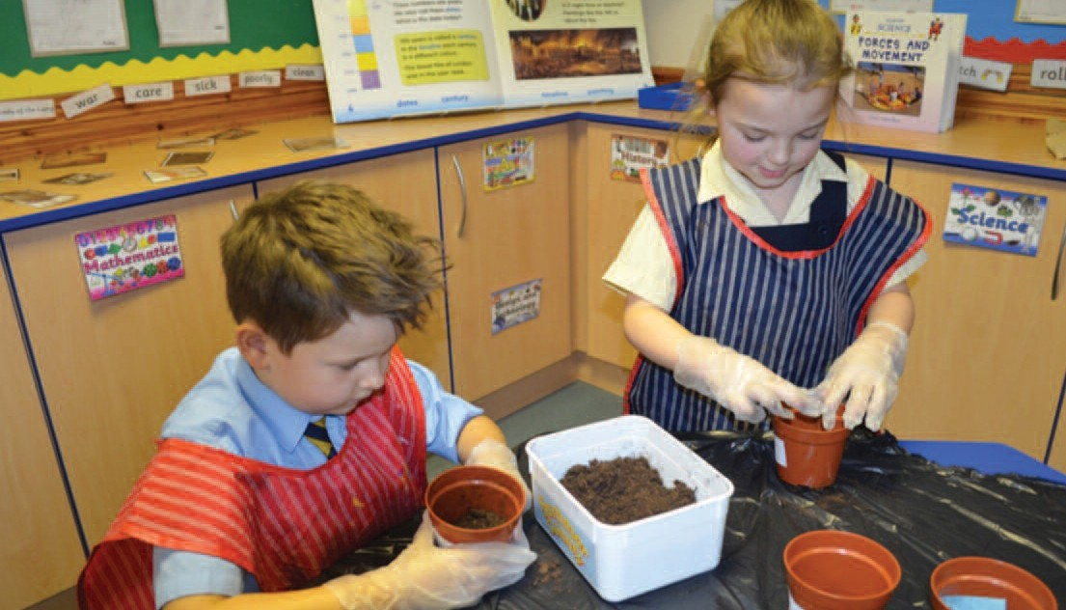

Literacy
We aim to provide pupils with a love and appreciation of our language both in a written and spoken context. Through studying English in as wide a range of forms as possible, pupils gain an understanding of how language can be manipulated to achieve a desired outcome. Spelling and grammar skills are taught proactively throughout the school year.

Mathematics
Maths is taught throughout the school by well qualified teachers, using a variety of methods suited to the individual needs of the children, and supported by appropriate, modern resources. Our spiral mathematics curriculum means that areas of learning are revisited and built on more frequently. Our regular and on-going assessment process means we are able to provide high levels of support for less able mathematicians, while taking the more able well ahead to explore advanced skills and develop their confidence when faced with complex problem-solving activities.
ICT
ICT at Green Meadow Independent Primary is taught as both a separate subject and an integral part of all subjects. This means the children learn the specific skills needed to use word-processing and data packages, and are then able to apply them in other subjects. The school has invested heavily in new hardware with computer workstations, interactive whiteboards and internet access in every room. We complement these with other resources that can be used in the classroom or outdoors such as tablets, digital cameras and recording devices.

Science
In Science, pupils develop their knowledge and understanding of scientific ideas and processes. They are encouraged to develop skills of prediction, ask questions, and make sensible evaluations based on their first-hand observations and experiences.

Core Subjects

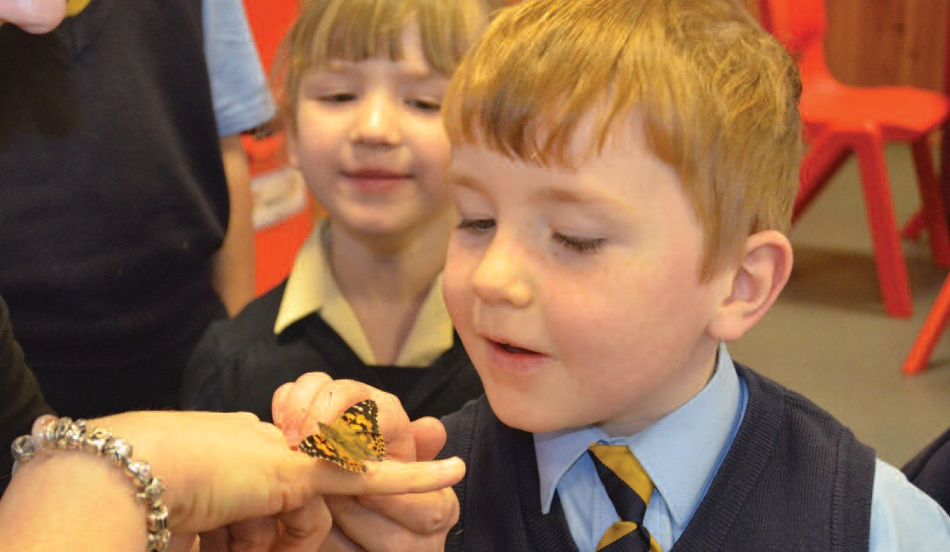

Children get off to a strong start in the early years. The curriculum is well-planned so that the children gain the knowledge and skills that they need to make a successful start in year 1
(Ofsted 2020)

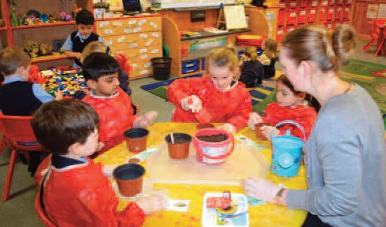

Foundation Subjects

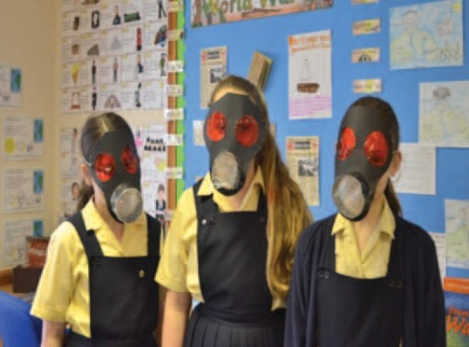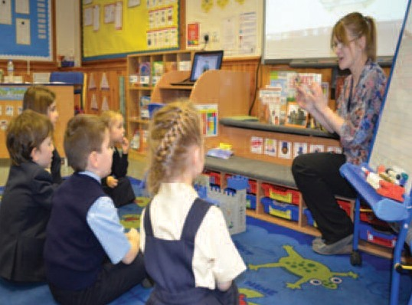

Leaders thread the values of respect, tolerance and diversity throughout the life of the school. There are regular activities to celebrate differences in people, cultures and religions, which encourage pupils to develop into caring and respectful citizens. Pupils’ spiritual, moral, social and cultural development is promoted well.
(Ofsted 2017)

History
All pupils study History in order to arouse interest in the past. It helps them to develop a sense of identity in time through learning about the development of Britain, Europe and the World. It also introduces them to what is involved in understanding and interpreting the past and to help them understand the present, in light of the past.
Pupils learn about continuity and change and will be able to use historical vocabulary to describe people, events and developments. There will be historical field trips to enrich learning and to broaden pupils' first-hand experiences.

Geography
In Geography the pupils learn about their local area and contrast this with other localities both in this country and abroad. They are taught about how culture and lifestyle is different depending on geographical location. The pupils explore physical geographical features such as rivers and mountains and discuss their impact on human life.

Religious Education
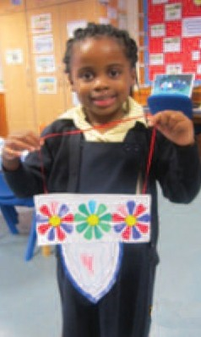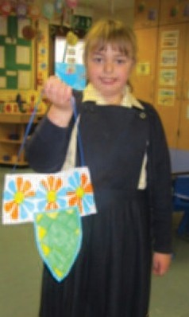We are not a religious school, though we aim to equip the pupils with knowledge and understanding of major world religions, and significant figures within those religions. A part of the lesson is spent in discussion, enabling each child to develop informed opinions, whilst learning to respect the views of those whose ideas are different from their own.

Foundation Subjects

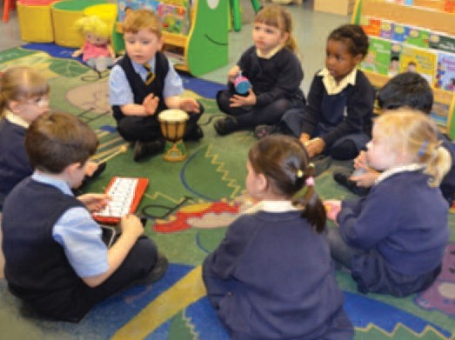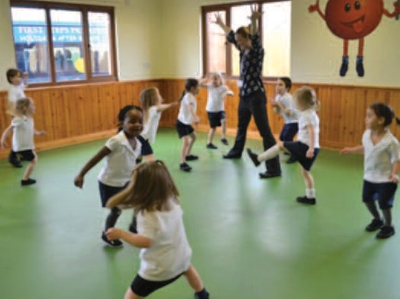

Music and Drama
Music and Drama play an important part in the life of the school. Children learn to make music together as a whole class and as they progress, in smaller groups. Children are encouraged to perform to increase their confidence.

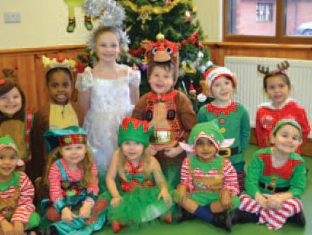

Modern Foreign Languages
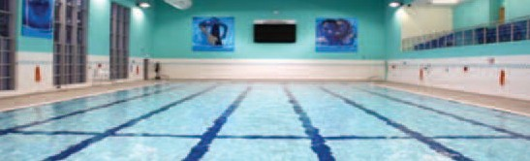At Green Meadow Independent Primary School, children have contact with modern languages and foreign cultures at an early stage, since we believe the development of pupil’s cultural awareness in all its aspects constitutes a vital part of young people's education. Throughout their time with us, we aim to build up pupil’s vocabulary, communication skills, and their awareness of different cultures and languages from around the globe. The lessons are fun, exciting and relevant to the pupils. Within the first two years, the focus lies on communication and the development of skills that might be beneficial to pupils when visiting a foreign country. Our main foreign language is Spanish.

Physical Education
The school is committed to delivering a high quality and varied PE curriculum. This includes a range of competitive, creative and challenge-type activities for individuals and as part of a team or group. All pupils are encouraged to participate for their own enjoyment, improvement and general well-being. We understand that PE develops children’s knowledge, skills and understanding, so that they can perform with increasing competence and confidence. It involves thinking, selecting and applying skills, and promotes positive attitudes towards a healthy lifestyle.
Thus, we enable them to make informed choices about physical activity throughout their lives. We use the local amenities for our sports activities such as football, basketball, badminton etc. For KS1 we use the school hall and outside area for PE lessons and other physical activities.
The pupils appreciate being taught in small groups. They said this helps them to learn more in class.
(Ofsted 2020)

Clubs and Extra-Curricular Activities

Introduction
We understand that families work/life balance has changed over time and more families are in need of care for their children before and after school. We meet the needs of families by offering this care.

Pupils play happily with each other during break and lunchtimes.
(Ofsted 2020)

Breakfast Club
Our breakfast club starts at 7.30am and breakfast will be served until 8.30am. Our breakfast club provides a sociable start to the day for many children who will be able to enjoy a breakfast of various cereals, toast, milk or juice or hot chocolate, whilst having a chat with their school friends. Games and activities are provided to keep pupils occupied until the start of the school day at 8.45am.

Afterschool Club
After-school care is available from 3.45pm to 6.30pm. The after-school clubhouse is well equipped with resources for craft activities, baking, books, games, puzzles, a Nintendo Wii, air hockey table and a computer etc. Children have a hot meal, which is served at approximately 4.15pm. The After-school club also have access to the outdoor play area and frequently take part in sport and gardening activities. We also have a fantastic outdoor play area with slides, tunnels, swings & climbing wall.

Holiday Club
Holiday Club is available during all school holidays and is from 7.15am to 6.30pm. Our club caters for all children of a primary school age. In the holiday club children are provided with all meals and snacks and take part in a full fun packed timetable of activities. Each week of the holiday club is themed such as, mini-beasts, pirates & princesses and winter wonderland. All crafts & baking activities, games & outdoor fun are tailored to the theme of the week.

Educational Day Visits & Visitors
During the academic year the children take part in educational day visits. The visits are designed to complement the classes curriculum and to promote additional learning to enhance and confirm what has been taught in class during a particular topic. Example of these days include local history walks, pumpkin picking during the festival of harvest, Warrington Museum and St Helen’s Glass.

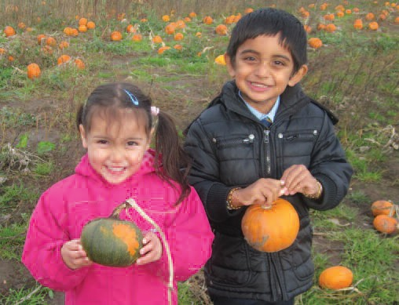

There are many opportunities to go on trips, such as pantomimes, museums and to a farm.
(Ofsted 2020)

The school also invites visitors into school to talk to the children about whom they are and what they do. These visitors include veterinary nurses, fire service personnel, story tellers from the local library service. These visits are used like the educational day trips to enhance the learning experiences of the children.

Extra Curricular Activities
Our Mini clubs are available for those pupils who want to access them. They are in addition to the school day either in the dinner break or after school. There is a mixture of educational and entertaining mini clubs such as Maths, English, music, crafts, baking, dance, choir etc. Some mini clubs have a small additional fee.

Clubs and Extra-Curricular Activities

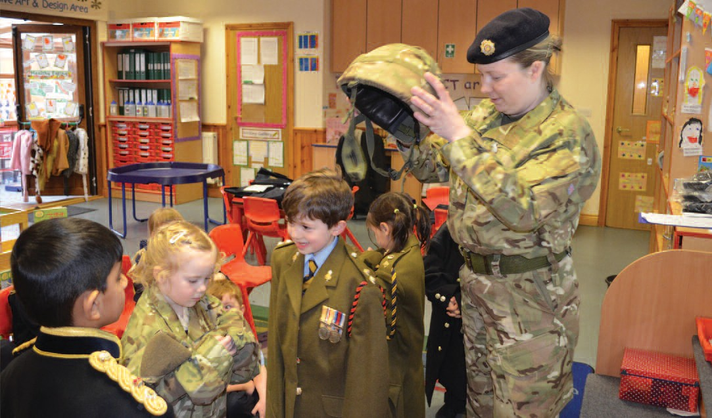

Pupils learn to help others. For example, they raise money for local and international charities. Pupils have chances to debate their own points of view and learn about different cultures and democracy through ‘themed weeks’.
(Ofsted 2020)

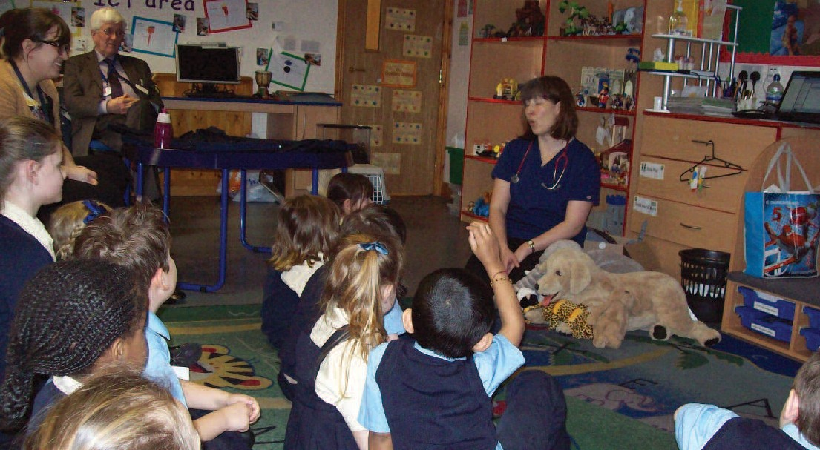

Our Classes

Kindergarten Class
The Early Years Foundation Stage (EYFS) applies to children in Kindergarten and Reception Class. At Green Meadow Independent Primary School all children join the Reception Class at the beginning of the school year. Children can join the Kindergarten the term after their 3rd birthday and we have three intakes, September, January and April. The EYFS is a very important part of your child’s education and development, and during these years most basic skills and attitudes to learning and socialising are established.

Reception Class
The children in our Reception and Kindergarten classrooms love the bright, warm, welcoming atmosphere. The classroom is laid out into different areas which echo the seven areas of learning identified in the Early Years Foundation Stage Curriculum. It promotes teaching and learning to ensure children’s ‘school readiness’ and gives children the broad range of knowledge and skills that provide the right foundation for good future progress through school and life. We believe that all children should experience the same opportunities and that they have an entitlement to a broad education that equips them with skills for life. We believe that praise is important and that every child should feel valued.
At Green Meadow Independent Primary School we believe that every child deserves the best possible start in life. High quality early learning provides the foundation children need to make the most of their abilities and talents as they begin to grow. We strive to offer support that enables them to fulfil their potential.
We aim to impart the shared values of respect for others and our environment, personal responsibility, tolerance and understanding of right and wrong, so that our pupils may become valued members of the community in which they live.

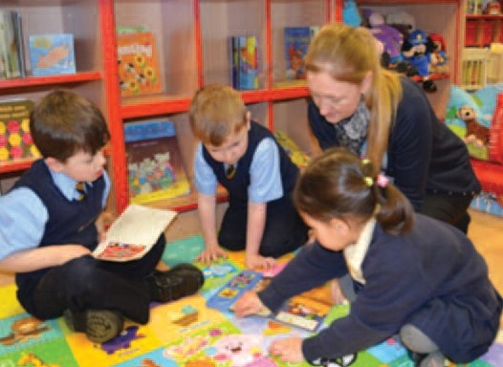
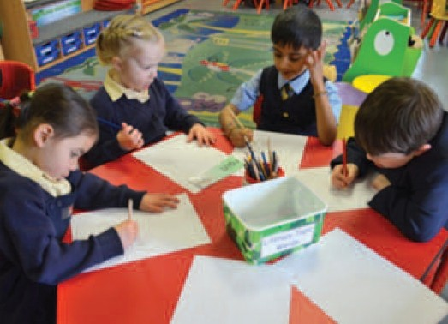We recognise the uniqueness of each child and value every child’s interests. We aim to deliver learning through a combination of adult led and child-initiated play, based on prior experiences and interests of the children. We teach children how to make considered choices in their learning and most importantly, the skills needed to be independent, lifelong learners. We value autonomous learning, so that the children reach their full potential while at the same time setting high attainment targets and making behavioural expectations clear and consistent. We aim to support children’s educational needs and to develop a working partnership between home and school to enable the children to develop in confidence and increasing independence.

Children in the early years Listen and concentrate well. The indoor and outdoor areas are stimulating and well-resourced. Children learn lots of exciting new things because activities build on what they already know.
(Ofsted 2020)

Our Classes

Key Stage 1
Our weekly assemblies are held within three age groups, the first being the Early Years which is Kindergarten and Reception Class who together discuss topics from the EYFS and Every Child Matters which is more relevant to these children’s age groups. The second and third are in key stage 1 & 2 groups and topics for discussion are varied and can be linked to either Religious Education such as celebrations of festivals or Personal, Social, Health Education (PSHE), such as, friendships, safety, healthy eating and personal achievements etc.
as Florence Nightingale and the Second World War. As the children progress from Prep 2 to Prep 3 they learn to take more responsibility for themselves and enter Key Stage 2 ready to take the next step in their journey through school life.

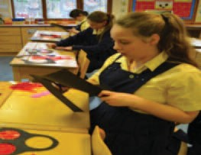Key Stage 2
Some of our Prep 6 class children creating their own World War 2 gas masks as part of their WW2 History Project

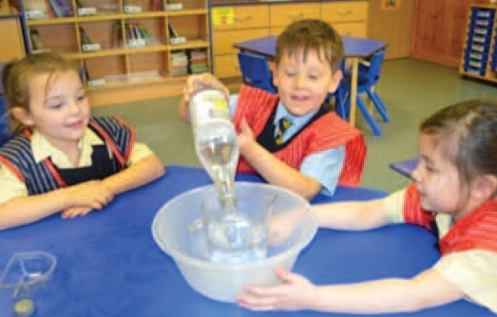In Key Stage 2 the children are encouraged to become more independent and self-sufficient. They work more independently with class teacher support and intervention at appropriate times in the lessons. The core subjects of English, Maths, and Science are taught at differing levels which encourages growth and challenges the individual. It is the decision of the class teacher as to the level a pupil works at and how to support the individual pupils in these subjects according to the needs of the particular year group.
Pupils said that the teachers make learning fun. Pupils particularly enjoy the wide range of practical activities on offer such as art and music
(Ofsted 2020)

In Key stage 1 the curriculum shifts towards a subject-based, more structured timetable. We continue to develop the phonic awareness and reading skills that have been introduced in Reception and build on the abilities of each individual child. Reading books are sent home each evening for the children to share with parents and weekly spellings are introduced. Subjects such as History and Geography are introduced through a range of topics such as Toys, Houses and Homes, The Victorians and Our School Environment. Our aim is to instill a love of learning and to encourage creative thinking from a young age. Educational visits play a part in this and really help to bring learning to life for young children.
As the children progress into Prep Two, we encourage greater independence and build on their developing self-confidence. Small amounts of homework are introduced, in order to prepare the children for the transition into Key Stage 2. Again, the curriculum is delivered through topics such

We carefully monitor children’s progress so that each pupil achieves their full potential. Each half term, reports are written on the pupils: this enables the parents of our pupils to be aware of what academic stage their child is at within the curriculum and for them to know also the progress their child has made. We have an excellent record regards pupils moving sub-levels above the expected national curriculum levels over the period of the academic year.
We work closely with pupils and their families getting them ready for life after Green Meadow in their chosen senior school, ensuring that the pupils are happy, confident, and knowledgeable of their next school. We do this through visits, discussions about other schools and correspondence with teachers of these other establishments.

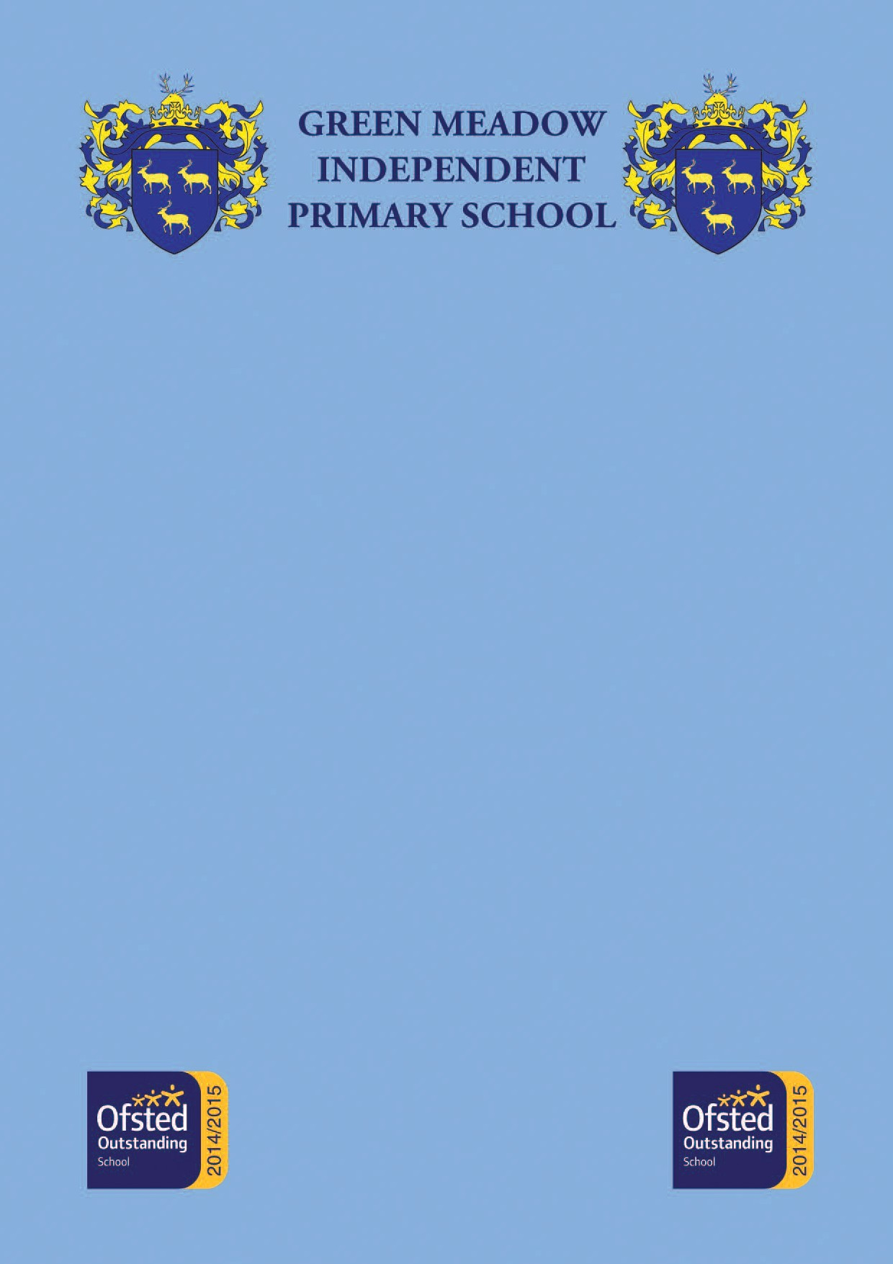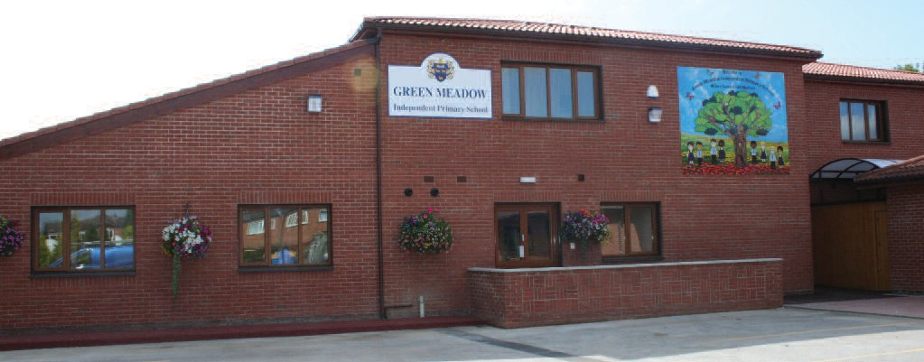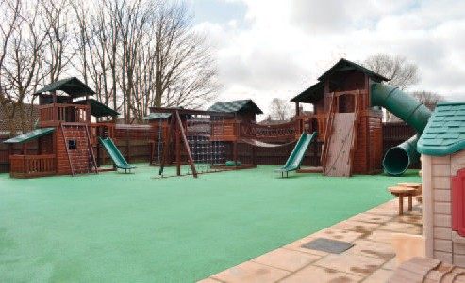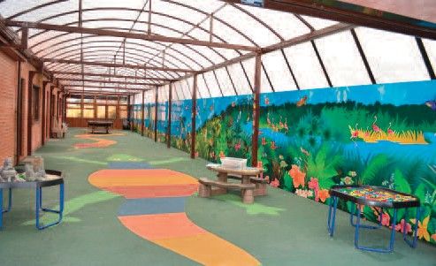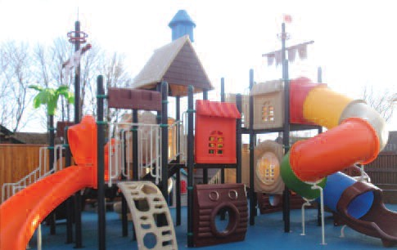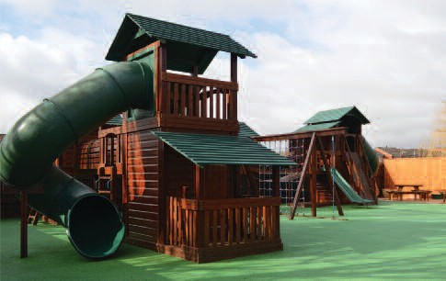

Robson Way Lowton Warrington WA3 2RD
Tel. 01942 671138 & 678803

